 | 
COUNCIL OF  THE EUROPEAN UNION |  |  | Brussels, 25 November 2008
 |  |  | DS 1168/08

WORKING DOCUMENT
from: | Czech Delegation
to: | Working Party on Civil Protection
Subject: | Programme of the Czech Presidency of the Council of the European Union in the field of civil protection

In preparation for the meeting of the Working Party on Civil Protection to be held on 1st December 2008, delegations will find annexed the programme of the Czech Presidency of the Council of the European Union in the field of civil protection.

ANNEX

PROGRAMME OF THE CZECH PRESIDENCY
OF THE COUNCIL OF THE EUROPEAN UNION IN THE FIELD
OF CIVIL PROTECTION:

IMPROVEMENTS IN THE PROTECTION OF PEOPLE AND PROPERTY –
CONTINUOUS CHALLENGE

The Czech Presidency aims to retain momentum in building European civil protection capabilities for the purpose of ensuring a fast and efficient response to natural and technological risks within Europe and also in the third countries.

One year after the adoption of the crucial documents establishing a Community Civil Protection Mechanism and a Civil Protection Financial Instrument, the Czech Presidency seeks to make further progress in the field of emergency response. In order to implement the requirements of these documents and comply with the request of the European Parliament, the Czech Presidency intends to initiate a broad debate on public awareness in event of major disasters as its main objective.

A) Challenge of public awareness- raising and training in the field of civil protection

Raising the awareness of EU citizens in the event of emergency situations
The aim of the initiative is to raise the awareness of the EU citizens in the field of civil protection to increase knowledge of prevention, of the kinds of warning in emergency situations and of appropriate behaviour during all types of emergencies. Discussion will be held in the three conceptual streams - the training of diplomatic personnel in the field of civil protection and humanitarian aid; public information and education aimed at the EU population; and prevention measures within the EU. The aim of the Czech Presidency is the adoption of the corresponding Council Conclusions at JHA Council in June.

Corresponding seminar:
The Czech Presidency, in cooperation with the European Commission, is organising the seminar on 18 - 20 February 2009 in Brno.

Setting up of the European disaster management training guidelines
Following the French Presidency's successful seminar and the adopted Council Conclusions, the Czech Presidency, in close cooperation with the Commission and the Council, will carry on preparatory work on guidelines regarding the implementation of certain aspects of the European Disaster Management Training Arrangements.

B) Challenge of achieving a more efficient EU emergency response

Critical Infrastructure Warning Information Network (CIWIN)
The Czech Presidency in cooperation with the Council and the Commission will continue the work on adoption of a Council Decision on the establishment of a Critical Infrastructure Warning Information Network (CIWIN).

C) EU Disaster Prevention challenge

Commission Communication on EU disaster prevention
EU disaster prevention is a priority theme within the EU civil protection field in the year 2009. After the adoption of the Commission Communication in early 2009, the Czech Presidency, in close cooperation with the Commission and the Council, will prepare proposals for corresponding Council Conclusions.

Annex 1

TIMETABLE OF EVENTS AND MEETINGS DURING THE CZECH PRESIDENCY OF THE COUNCIL OF THE EU

JANUARY 2009 | 14 January: WG PROCIV  14 January: Evening welcoming party hosted by the Czech Presidency,  Czech Permanent Representation, Rue Caroly 15, Bruxelles – Ixelles  19 – 22 January: Symposium on Cartography and Geoinformatics for Early Warning and Emergency Management in Prague
FEBRUARY 2009 | 11 February: “112 Day” - Presentation in the European Parliament  13 February: WG PROCIV  18, 19 and 20 February: Seminar on public awareness -raising in the event of major disasters in Brno
MARCH 2009 | 12 March: WG PROCIV
APRIL 2009 | 2 April: WG PROCIV  22, 23 and 24 April: Meeting of Directors-General for Civil Protection in Prague
MAY 2009 | 14 May: WG PROCIV
JUNE 2009 | 4 and 5 June: JHA Council in Brussels.  Adoption of conclusions on civil protection by the Home Affairs Ministers for forwarding to Council  9 June: WG PROCIV

Annex 2

CZECH PRESIDENCY TEAM MEMBERS:

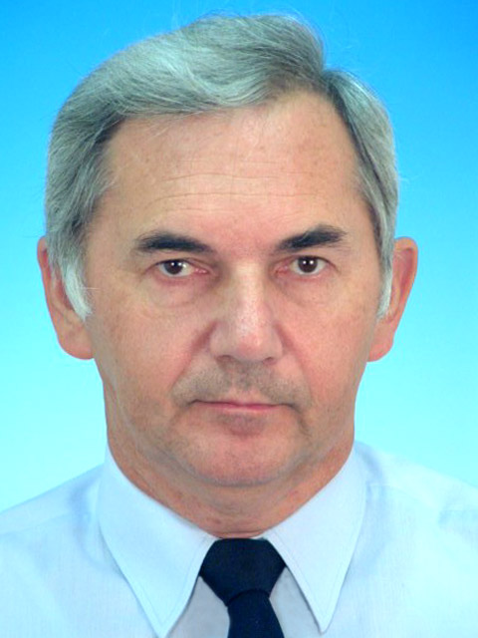  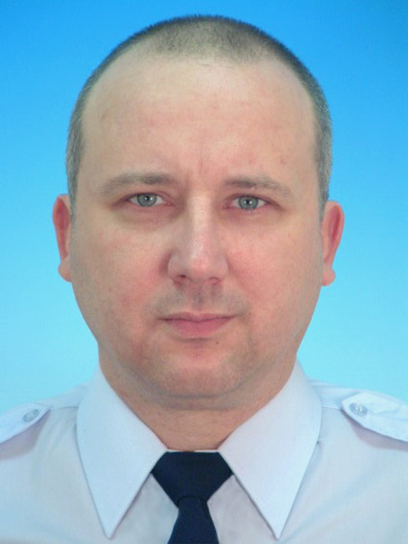  Miroslav Štěpán  Director – General of FRS CR  MI - DG FRS CR  Kloknerova 26  148 01, Prague 414  Tel: +420 950 819 220  Fax: +420 950 819 960  miroslav.stepan@grh.izscr.cz |  | Miloš Svoboda  Vice Director – General of FRS CR  responsible for CZ PRES  MI - DG FRS CR  Kloknerova 26  148 01, Prague 414  Tel: +420 950 819 223  Fax: +420 950 819 962  milos.svoboda@grh.izscr.cz
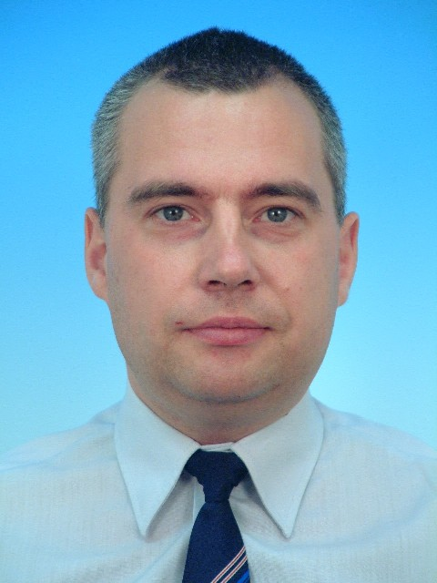  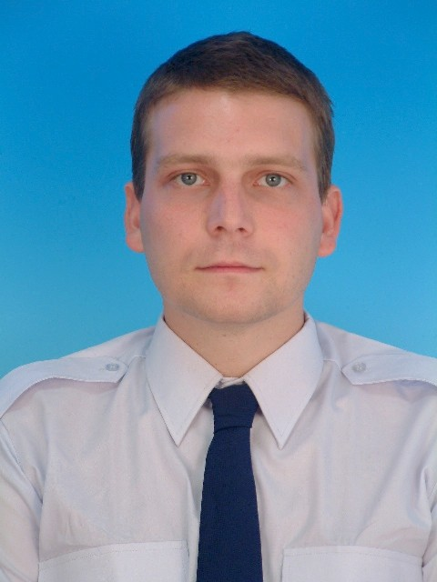  Jiří Chalupa  Chairman of WG PROCIV  15, rue Caroly  1050 Brusel  Belgie  Tel: +32 2 2139 346  Fax: +32 2 2139 287  jiri.chalupa@seznam.cz |  | Jiří Musílek  Vice - Chairman of WG PROCIV  MI - DG FRS CR  Kloknerova 26  148 01, Prague 414  Tel: +420 950 819 747,  GSM: +420 724 178 019  jiri.musilek@grh.izscr.cz
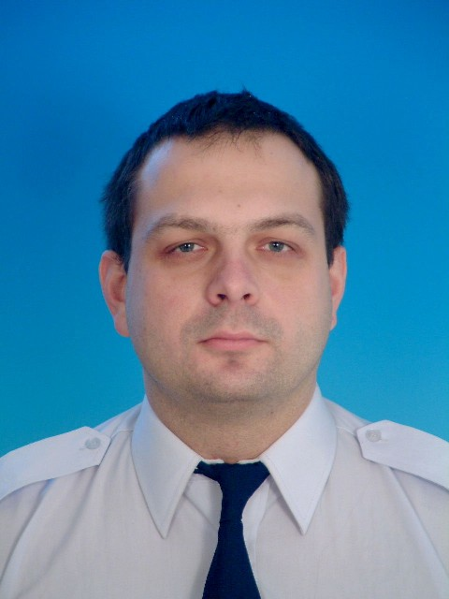    Daniel Dittrich  National delegate to WG PROCIV  MI - DG FRS CR  Kloknerova 26  148 01, Prague 414  Tel: +420 950 819 798,  GSM: +420 724 178 410  daniel.dittrich@grh.izscr.cz |  | Roman Francl  National delegate alternate to WG PROCIV  MI - DG FRS CR  Kloknerova 26  148 01, Prague 414  Tel: +420 950 819 876,  GSM: +420 724 193 396  roman.francl@grh.izscr.cz
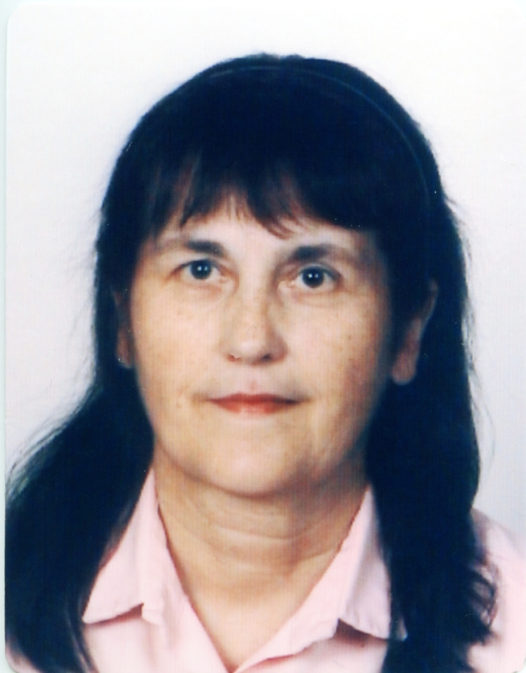  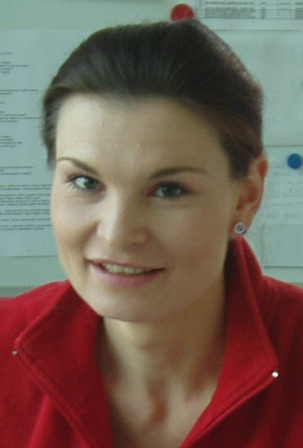  Helena Hanzlíková  Responsible for EPCIP/CIWIN  MI - DG FRS CR  Kloknerova 26  148 01, Prague 414  Tel: +420 950 819 875  Fax: +420 950 819 609  helena.hanzlikova@grh.izscr.cz |  | Lenka Uhlířová  Responsible for Events Organisation  MI - DG FRS CR  Kloknerova 26  148 01, Prague 414  Tel: +420 950 819 863  GSM: +420 724 193 402  lenka.uhlirova@grh.izscr.cz

  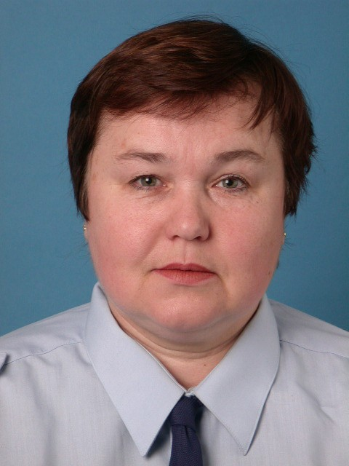  Milena Bohuslavská  Responsible for International Relationships  MI - DG FRS CR  Kloknerova 26  148 01, Prague 414  Tel: +420 950 819 261  GSM: +420 724 173 196  milena.bohuslavska@grh.izscr.cz |  | Adéla Laubeová  CZ PRES support  FRS of Prague region  Roháčova 81  130 00, Prague 3  Tel: +420 242 410 385  GSM: +420 723 941 831  laubeova@hzspraha.cz
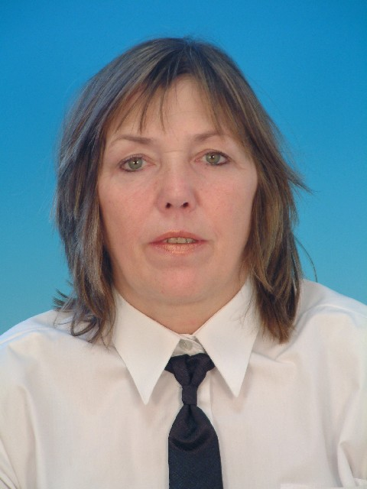    Jaromíra Pokorná  CZ PRES support  MI - DG FRS CR  Kloknerova 26  148 01, Prague 414  Tel: +420 950 370 261  GSM: +420 724 193 399  jaromira.pokorna@grh.izscr.cz |  | Pavel Špulák  CZ PRES support  MI - DG FRS CR  Kloknerova 26  148 01, Prague 414  Tel: +420 950 819 851  GSM: +420 724 178 011  pavel.spulak@grh.izscr.cz
  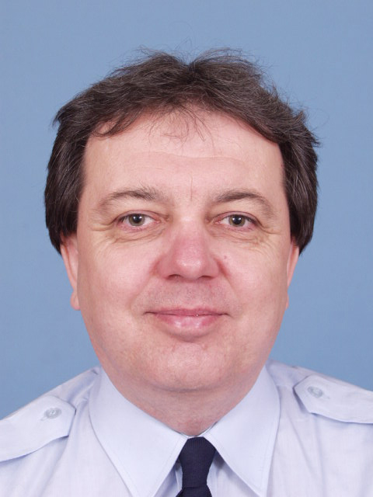  Romana Janů  CZ PRES support  FRS of Prague region  Roháčova 81  130 00, Prague 3  Tel: +420 242 410 375  GSM: +420 731 011 698  janu@hzspraha.cz |  | Zdeněk Šach  CZ PRES support  FRS of Vysočina region  Humpolecká 3606  580 01, Havlíčkův Brod  Tel: +420 950 275 127  GSM: +420 606 448 615  zdenek.sach@hasici-vysocina.cz
__________________________

